Dickey Betts Band  Lone Star Roadhouse, New York City  11/01/88  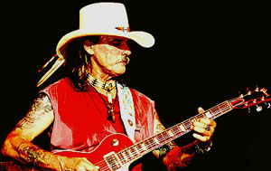 |   - Introduction  - Rock Bottom  - Blue Sky  - Time To Roll  - Duane’s Tune  - The Blues Ain’t Nothin’  - Far Cry  - Heartbreak Line  - In Memory Of Elizabeth Reed  - Jessica  - Under The Guns Of Love  - Statesboro Blues  - One Way Out  - Rock ‘n’ Roll Hoochie Coo  - Spoonful  - Southbound

