Gov’t Mule  Barre Chord, Toms River, NJ  August 18, 1995  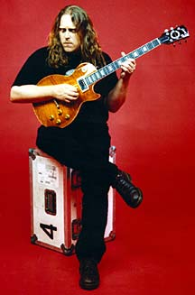   | Disc 1  1) Mule  2) Rocking Horse  3) Mr. Big  4) Temporary Saint  5) St. Stephen Jam  6) Monkey Hill  7) The Same Thing  Disc 2  1) Don't Step On the Grass Sam  2) Gambler's Roll  3) Politician  4) Blind Man in the Dark  5) Just Got Paid  6) End of the Line  7) Yonder Wall  8) Gov't Mule Radio Promos

