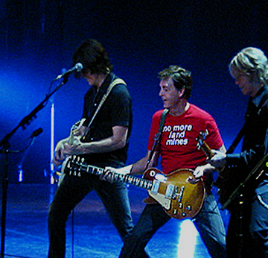
Paul McCartney
Live in Cleveland
Gund Arena
4/29/02

