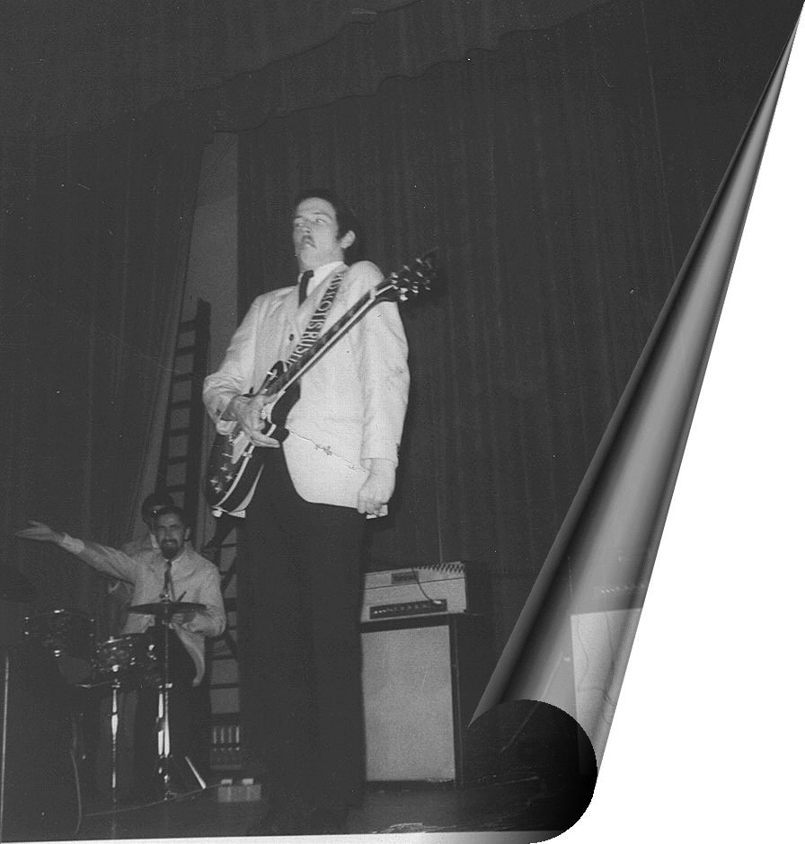
John Mayall: harmonica, keyboards, vocals; Eric Clapton: guitar (tracks 1-9, 11-19); John McVie: bass (tracks 1-6, 13-20);
Jack Bruce: bass (tracks 7-12); Hughie Flint: drums.

Recorded 26 April 1965, BBC Radio:
1. Crawling Up A Hill
2. Crocodile Walk
3. Bye Bye Bird

Immediate Records Sessions, May or June 1965
[Originally released as singles, except 6 on the
album Blues Anytime, Vol. 1]:
4. I'm Your Witchdoctor
5. Telephone Blues
6. On Top Of The World

Recorded 28 November 1965, live at
the Flamingo Club, London:
7. (Intro) - Maudie
8. It Hurts To be In Love
9. Have You Ever Loved A Woman
10. Bye Bye Bird
11. Hoochie Coochie Man
12. (They Call It) Stormy Monday

Purdah single, recorded February 1966,
released August 1966:
13. Lonely Years
14. Bernard Jenkins

Recorded 19 March 1966, Saturday Club,
BBC Radio [* denotes previously unreleased recordings]:
15. On Top Of The World
16. Key To Love
17. Hideaway*
18. Little Girl*
19. Tears In My Eyes*
20. Parchman Farm



