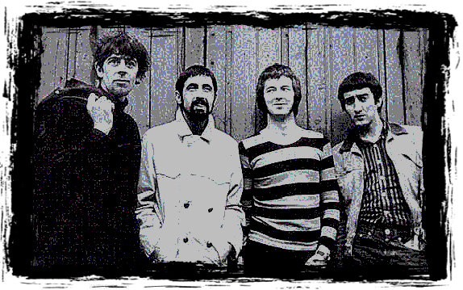
3br
1. Crawling Up A Hill
2. Crocodile Walk
3. Bye Bye Bird
4. I’m Your
Witchdoctor
5. Telephone Blues
6. On Top Of
The World
7. Maudie
8. It Hurts To
Be In Love
9. Have You Ever
Loved A Woman
10. Bye Bye Bird
11. Hoochie Coochie
Man
12. (They Call It)
Stormy Monday
13. Lonely Years
14. Bernard Jenkins
15. On Top Of
The World
16. Key To Love
17. Hideaway*
18. Little Girl*
19. Tears In My Eyes*
20. Parchman Farm*

* denotes previously unreleased recordings

3BR presents the “rest of the story”…the complete known-to-exist recordings of the legendary

John Mayall’s Bluesbreakers
featuring Eric Clapton.
Live performances, singles and the
rare BBC recordings are collected in one place
for the first time.

Research and Archival Material: DN
Coordination, Art and Persuasion: Igor
Remastering and Compilation: The Professor
