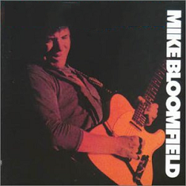
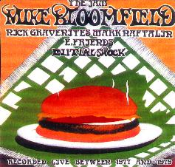

1) Eyesight to the Blind
2) Women Lovin' Each Other
3) Linda Lou
4) Kansas City
5) Blues in B-Flat
6) Medley: Darktown Strutter's Ball /
Mop Mop / Call Me a Dog
7) I'm Glad I'm Jewish
8) Jockey Blues
9) Between the Hard Place and the Ground
10) Don't Lie to Me
11) Cherry Red
12) Uncle Bob's Barrelhouse Blues
13) Wee Wee Hours
14) Vamp in C
15) One of These Days

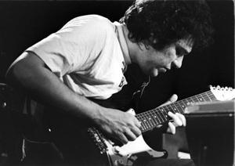

Mike Bloomfield Initial Shock

Mike Bloomfield Initial Shock
Mike Bloomfield - Initial Shock
Recorded live 1977-1979

1) Eyesight to the Blind
2) Women Lovin' Each Other
3) Linda Lou
4) Kansas City
5) Blues in B-Flat
6) Medley: Darktown Strutter's Ball / Mop Mop / Call Me a Dog
7) I'm Glad I'm Jewish
8) Jockey Blues
9) Between the Hard Place and the Ground
10) Don't Lie to Me
11) Cherry Red
12) Uncle Bob's Barrelhouse Blues
13) Wee Wee Hours
14) Vamp in C
15) One of These Days

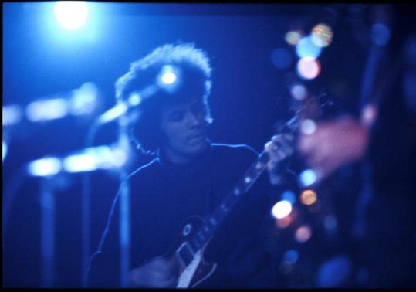

M
I
K
E

B
L
O
O
M
F
I
E
L
D

