Roy Buchanan  American Music Hall, San Francisco  August 1st 1978  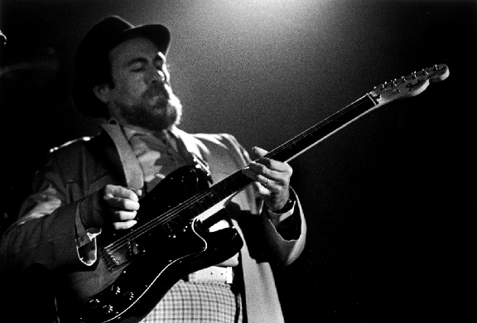 | - 1841 Shuffle  - Hot cha  - Tell Me Where You’re At  - Slowdown  - Sweet Dreams  - Change My Mind  - Lonely Nights  - My Soul Died Last Friday  - Hey Joe  - Foxy Lady  