Roy Buchanan  Ubinchokin Hall, Nagoya  June 1977  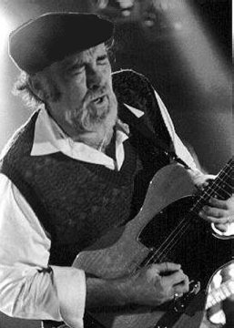 | - Soul Dressing  - Sweet Honeydew  - Tribute to Elmore James  - Hey Joe  - Foxy Lady  - Slow Down  - Lonely Days, Lonely Nights  - She Can't Say No  - My Baby Says She's Gonna Leave Me  10.Sweet Dreams  11.Blues Jam

