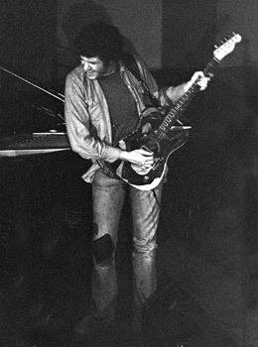
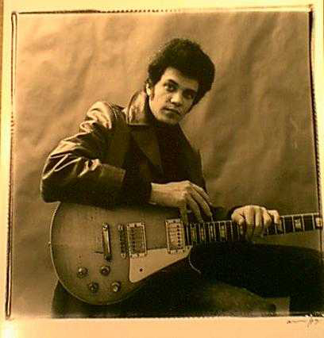
Mike Bloomfield & Friends Again
Fillmore West, San Francisco, California

MIKE BLOOMFIELD

DISC ONE
February 1, 1969

1. Born In Chicago
2. Work Me Lord
3. Killing My Love
4. Holy Moly
5. My Heart Beat Like A Hammer
6. It’s About Time
7. Schoolgirl

DISC TWO
February 2, 1969

1. Born In Chicago
2. Blues On The West Side
3. It’s About Time
4. Sweet Little Angel
5. Blues Jam

AND FRIENDS AGAIN

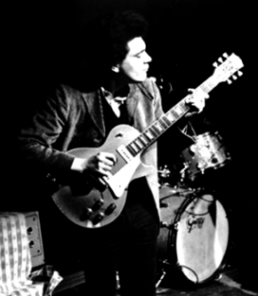

Mike Bloomfield & Friends Again
Mike Bloomfield & Friends Again
Mike Bloomfield & Friends Again
Fillmore West, San Francisco, California

DISC ONE
February 1, 1969

1. Born In Chicago
2. Work Me Lord
3. Killing My Love
4. Holy Moly
5. My Heart Beat Like A Hammer
6. It’s About Time
7. Schoolgirl

DISC TWO
February 2, 1969

1. Born In Chicago
2. Blues On The West Side
3. It’s About Time
4. Sweet Little Angel
5. Blues Jam

