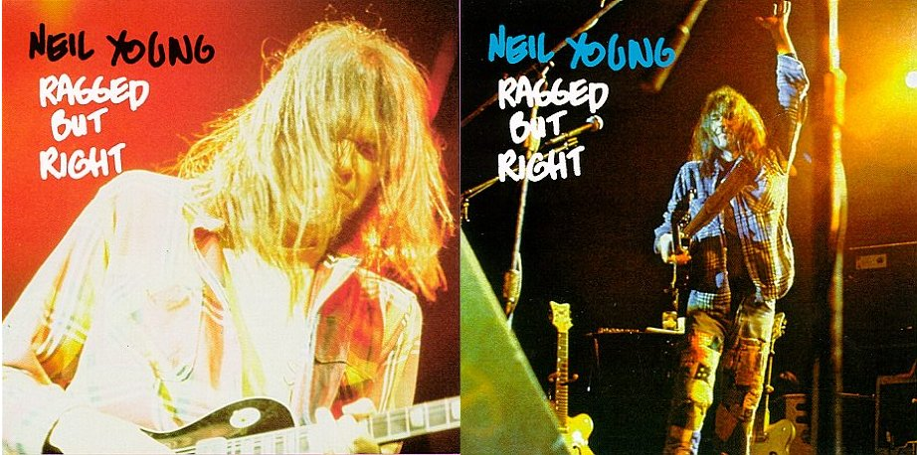

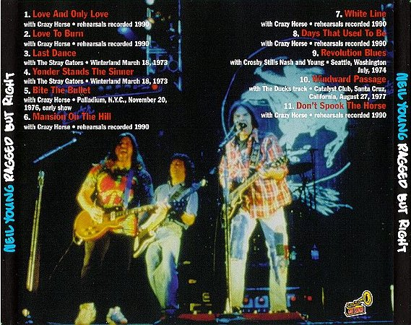

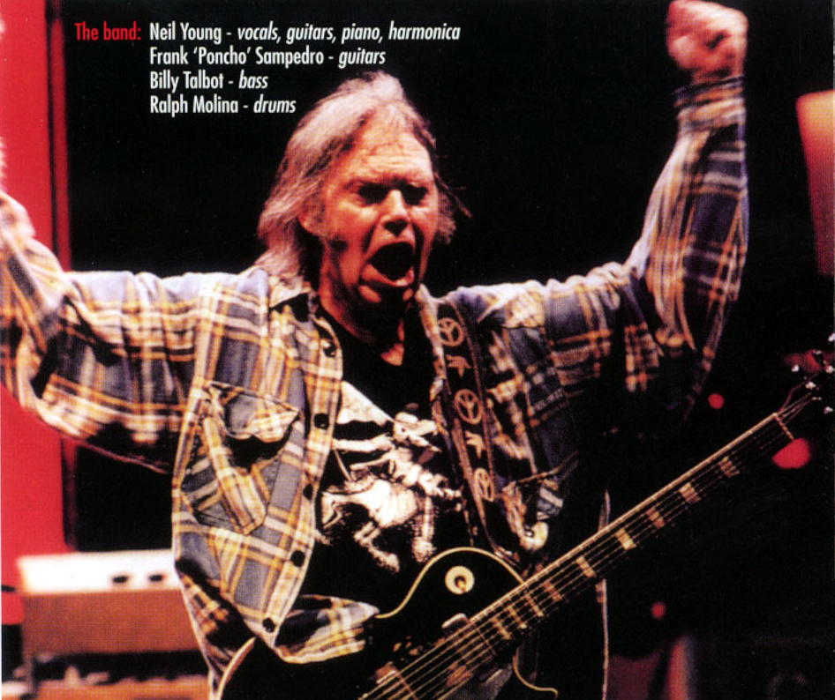

RAGGED BUT RIGHT is a haphazardly put together disc, in both packaging and contents. Nonetheless, it's got some excellent material and has very fine sound quality. The packaging is ultra-cheap, with no liner notes and only a thin, unevenly cut picture on the sleeve. However, the back of the CD indicates the sources of the disc's eleven tracks.
Six of the tracks come from 1990 rehearsals for either the Ragged Glory album or subsequent tour: "Love and Only Love", "Love to Burn", "Mansion on the Hill", "White Line", "Days That Used to Be", and "Don't Spook the Horse”. The sound quality of these tracks is very clear and the performances are all very good. They are not all that different than the album versions, but are generally less polished and more passionate. "Don't Spook the Horse" is the real treat among these cuts, since it's only available as the bonus track on the hard-to-find "Mansion on the Hill" CD single.

The other five tracks are all live performances from different tours during the seventies. All are of good sound quality without noticeable hiss and minimal crowd noise. "Last Dance" and "Yonder Comes the Sinner" are listed as being performed with the Stray Gators at the Winterland, March 18, 1993. Neither is Neil's greatest song, but they are good performances with some solid guitar/pedal steel interplay on "Last Dance", "Bite the Bullet" is with Crazy Horse at the Palladium, NYC, Nov. 20, 1976, early show. It's a decent performance of a sub-standard song. "Revolution Blues" is with CSNY in Seattle, July 1974. It's a real treat to hear CSNY sound as dark and intense as they do on this performance.

Finally, "Windward Passage" is with the Ducks from the Catalyst Club in Santa Cruz, August 27, 1977. This is a fantastic find, since neither the song nor anything performed with the short-lived Ducks has ever been officially released. An instrumental written by Neil, it features a magnificent soaring guitar. Unlike anything he's released, "Windward Passage" suggests that it's a shame he hasn't explored this type of composition at other times.
Overall, the album contains solid material with clear sound quality. There isn't much reason behind the contents, but it's all worth having. The real treats are the closing tracks, "Windward Passage" and "Don't Spook the Horse". (B+)

